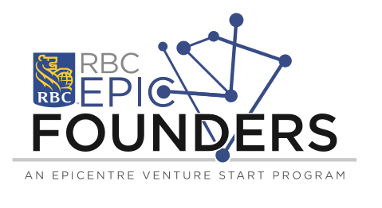

Application for 2018 RBC EPIC Founders Program
Applications Due: March 31, 2018
The RBC EPIC Founders Program offers students or alumni $6,000 to work on their business and prototype full time (35 hrs/week) over a 12-week period from May 7 to July 27, 2018 and present their progress at Pitch Day on July 27, 2018.

To be eligible for the RBC EPIC Founders Program you must fulfill the following requirements:

- University of Windsor and St. Clair College students or recent alumni graduated within the last 7 years (post 2011)
- Under 29 years of age
- Business idea must be based in Windsor
- Must show some evidence of attempted idea validation (customer interviews, expert consultation, attendance in EPICentre events or programming etc.)
- Not working full time
- Must dedicate 35 hours a week to work on business
- Available Monday to Friday, 8:30am to 4:30pm from May 7 to July 27, 2018 and for Pitch Day on July 27, (excluding holidays) and occasional nights and weekends
- Must be eligible to work in Canada
Application Process:

Round 1: Formal Application

Applicants will be required to answer the attached questions describing their business/business idea and the steps taken towards validation of this business/business idea.

Upon completion of this application, please submit your completed application to Nicole Anderson: nicolea@uwindsor.ca

Applications will be reviewed, and successful applications will proceed to Round 2

Round 2: Idea Pitch

Upon successful completion of Round 1, applicants will be required to pitch their idea in front of a panel of judges. Final selection will take place shortly after, and successful applicants will be admitted into the RBC EPIC Founders Program.

Program Start Date: May 7, 2018
Program End Date: July 27, 2018
Pitch Day: July 27, 2018

Application Date:
Venture and Contact Information
Venture/Project Name:
Primary Contact Name:
RBC EPIC Founder Members
(including primary contact person- Maximum of two team members are eligible to receive funding)
 | Name | Title | Home Address, Province, Postal Code
1.
2.
Additional Team Members
 | Name | Title | Home Address, Province, Postal Code
1.
2.
3.
4.

 | Phone | Email
1.
2.
3.
4.

 | University/College | Faculty/Degree | Graduation/ Expected Graduation Date
1.
2.
3.
4.

Business Idea
What is your idea?
What problem does your idea wish to solve?
What is your value proposition? (What makes your products/services better? Why would your customers choose your products/services over competitors?)
Who will be your customers? (Which group(s) of customer(s) will you target?)
What is the size of the market?
What is your revenue model? (How will your business make money?)
What steps have you taken to develop on your business idea? Any success to date?

Intellectual Property (IP)
Will your idea generate any intellectual property (patents, copyrights, trademarks):
Please provide details of the IP(s):

Referral
How do you find out about us?
If other, please specify:

Additional Comments

If available, please include a copy of your business plan, business model canvas, and/or any other relevant information with the completed application form.

Submit completed application by March 31, 2018 to Program and Events Lead, Nicole Anderson at nicolea@uwindsor.ca

You may be asked to present to the Committee. Final decision is at the discretion of the Committee.

